Name: Shubham Shashwat
Roll no.: 244CA053
Assignment 5

1. Create the following tables with the following attributes and constraints on them.
a. Bank (bk_code, bk_name, bk_address)
b. Branch (br_id, br_name, br_address, bk_code)
c. Customer (cust_ID, cust_name, phone_no, address)
d. Account (acc_no, acc_type, balance, br_id)
e. Customer_Account (cust_ID, acc_no)
f. Loan (loan_ID, loan_type, amount, br_id)
g. Customer_Loan (cust_ID, loan_ID)

1. Create all the tables by defining primary key, foreign key and other appropriate constraints.

CREATE TABLE Bank (
bk_code VARCHAR(10) PRIMARY KEY,
bk_name VARCHAR(30) NOT NULL,
bk_address VARCHAR(30) NOT NULL);
CREATE TABLE Branch (
br_id VARCHAR(10) PRIMARY KEY,
br_name VARCHAR(30) NOT NULL,
br_address VARCHAR(30) NOT NULL,
bk_code VARCHAR(10) NOT NULL,
FOREIGN KEY (bk_code) REFERENCES Bank(bk_code) ON DELETE CASCADE
);

CREATE TABLE Customer (
cust_ID NUMBER PRIMARY KEY,
cust_name VARCHAR(30) NOT NULL,
phone_no VARCHAR(20) NOT NULL,
address VARCHAR(30) NOT NULL
);

CREATE TABLE Account (
acc_no NUMBER PRIMARY KEY,
acc_type VARCHAR(50) NOT NULL,
balance NUMBER(10, 2) NOT NULL,
br_id VARCHAR(10) NOT NULL,
FOREIGN KEY (br_id) REFERENCES Branch(br_id) ON DELETE CASCADE
);

CREATE TABLE Customer_Account (
cust_ID NUMBER NOT NULL,
acc_no NUMBER NOT NULL,
PRIMARY KEY (cust_ID, acc_no),
FOREIGN KEY (cust_ID) REFERENCES Customer(cust_ID) ON DELETE CASCADE,
FOREIGN KEY (acc_no) REFERENCES Account(acc_no) ON DELETE CASCADE
);

CREATE TABLE Loan (
loan_ID NUMBER PRIMARY KEY,
loan_type VARCHAR(50) NOT NULL,
amount NUMBER(10, 2) NOT NULL,
br_id VARCHAR(10) NOT NULL,
FOREIGN KEY (br_id) REFERENCES Branch(br_id) ON DELETE CASCADE
);

CREATE TABLE Customer_Loan (
cust_ID NUMBER NOT NULL,
loan_ID NUMBER NOT NULL,
PRIMARY KEY (cust_ID, loan_ID),
FOREIGN KEY (cust_ID) REFERENCES Customer(cust_ID) ON DELETE CASCADE,
FOREIGN KEY (loan_ID) REFERENCES Loan(loan_ID) ON DELETE CASCADE
);

2. Insert atleast five records in each table.
INSERT ALL
INTO Bank (bk_code, bk_name, bk_address) VALUES ('BK01', 'State Bank of India', 'Mumbai')
INTO Bank (bk_code, bk_name, bk_address) VALUES ('BK02', 'ICICI Bank', 'Delhi')
INTO Bank (bk_code, bk_name, bk_address) VALUES ('BK03', 'HDFC Bank', 'Bangalore')
INTO Bank (bk_code, bk_name, bk_address) VALUES ('BK04', 'Axis Bank', 'Chennai')
INTO Bank (bk_code, bk_name, bk_address) VALUES ('BK05', 'Punjab National Bank', 'Kolkata')
SELECT 1 FROM dual;

INSERT ALL
INTO Branch (br_id, br_name, br_address, bk_code) VALUES ('BR01', 'Downtown Branch', 'Mumbai', 'BK01')
INTO Branch (br_id, br_name, br_address, bk_code) VALUES ('BR02', 'MG Road Branch', 'Bangalore', 'BK02')
INTO Branch (br_id, br_name, br_address, bk_code) VALUES ('BR03', 'NITK Branch', 'Surathkal', 'BK03')
INTO Branch (br_id, br_name, br_address, bk_code) VALUES ('BR04', 'Surat Branch', 'Surat', 'BK04')
INTO Branch (br_id, br_name, br_address, bk_code) VALUES ('BR05', 'Pune Branch', 'Pune', 'BK05')
SELECT 1 FROM dual;

INSERT ALL
INTO Customer (cust_ID, cust_name, phone_no, address) VALUES (101, 'Ravi Kumar', '9876543210', 'Mumbai')
INTO Customer (cust_ID, cust_name, phone_no, address) VALUES (102, 'Sita Patel', '9876543211', 'Bangalore')
INTO Customer (cust_ID, cust_name, phone_no, address) VALUES (103, 'Amit Sharma', '9876543212', 'Delhi')
INTO Customer (cust_ID, cust_name, phone_no, address) VALUES (104, 'Neha Rani', '9876543213', 'Chennai')
INTO Customer (cust_ID, cust_name, phone_no, address) VALUES (105, 'Kiran Singh', '9876543214', 'Kolkata')
SELECT 1 FROM dual;

INSERT ALL
INTO Account (acc_no, acc_type, balance, br_id) VALUES (201, 'savings', 5000, 'BR01')
INTO Account (acc_no, acc_type, balance, br_id) VALUES (202, 'current', 10000, 'BR02')
INTO Account (acc_no, acc_type, balance, br_id) VALUES (203, 'savings', 15000, 'BR03')
INTO Account (acc_no, acc_type, balance, br_id) VALUES (204, 'current', 20000, 'BR04')
INTO Account (acc_no, acc_type, balance, br_id) VALUES (205, 'savings', 3000, 'BR05')
SELECT 1 FROM dual;

INSERT ALL
INTO Customer_Account (cust_ID, acc_no) VALUES (101, 201)
INTO Customer_Account (cust_ID, acc_no) VALUES (102, 202)
INTO Customer_Account (cust_ID, acc_no) VALUES (103, 203)
INTO Customer_Account (cust_ID, acc_no) VALUES (104, 204)
INTO Customer_Account (cust_ID, acc_no) VALUES (105, 205)
SELECT 1 FROM dual;

INSERT ALL
INTO Loan (loan_ID, loan_type, amount, br_id) VALUES (301, 'Home Loan', 200000, 'BR01')
INTO Loan (loan_ID, loan_type, amount, br_id) VALUES (302, 'Personal Loan', 50000, 'BR02')
INTO Loan (loan_ID, loan_type, amount, br_id) VALUES (303, 'Vehicle Loan', 150000, 'BR03')
INTO Loan (loan_ID, loan_type, amount, br_id) VALUES (304, 'Home Loan', 300000, 'BR04')
INTO Loan (loan_ID, loan_type, amount, br_id) VALUES (305, 'Personal Loan', 100000, 'BR05')
SELECT 1 FROM dual;

INSERT ALL
INTO Customer_Loan (cust_ID, loan_ID) VALUES (101, 301)
INTO Customer_Loan (cust_ID, loan_ID) VALUES (102, 302)
INTO Customer_Loan (cust_ID, loan_ID) VALUES (103, 303)
INTO Customer_Loan (cust_ID, loan_ID) VALUES (104, 304)
INTO Customer_Loan (cust_ID, loan_ID) VALUES (105, 305)
SELECT 1 FROM dual;

3. List the details of all customers.

SELECT * FROM CUSTOMER;
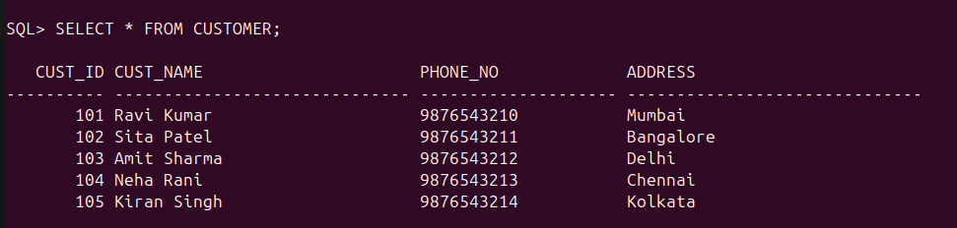
4. Find the cust_ID and phone number of customer ‘Ravi’.

SELECT CUST_ID,CUST_NAME, PHONE_NO FROM CUSTOMER
2 WHERE CUST_NAME like 'Ravi%';
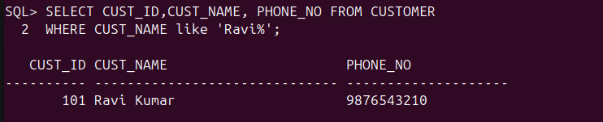
5. Find the Address of all branches of br_01.

SELECT BR_ADDRESS FROM BRANCH WHERE BR_ID='BR01';

6. Find the details of Customer having ID 103.

SELECT * FROM CUSTOMER WHERE CUST_ID= 103;
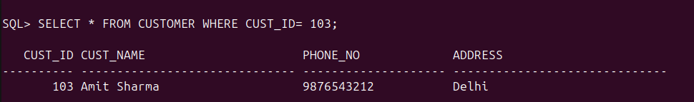
7. List the account details having balance more than 10000.

SELECT * FROM ACCOUNT WHERE BALANCE>10000;
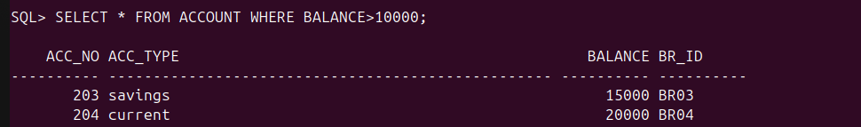
8. List the account details of branch br_02.

SELECT * FROM ACCOUNT WHERE BR_ID='BR02';
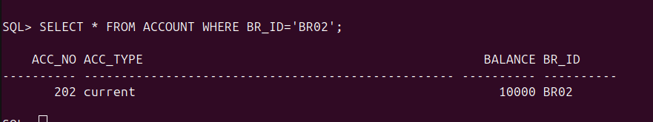
9. List the loan details of branch br_01.

SELECT * FROM LOAN WHERE BR_ID= 'BR01';
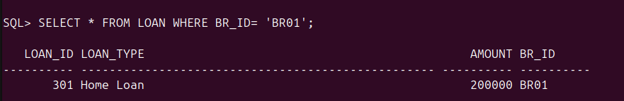

10. List the account details with their branch address.
SELECT ACC_NO, ACC_TYPE, BALANCE, A.BR_ID, B.BR_ADDRESS FROM ACCOUNT A JOIN BRANCH B ON A.BR_ID=B.BR_ID;
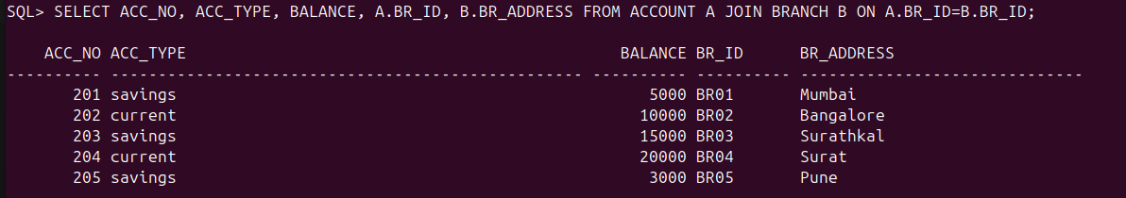
11. List the customer details with their account details.
SELECT C.CUST_ID, C.CUST_NAME, C.PHONE_NO, C.ADDRESS, CA.ACC_NO, A.ACC_TYPE, A.BALANCE,A.BR_ID
FROM CUSTOMER C JOIN CUSTOMER_ACCOUNT CA ON C.CUST_ID=CA.CUST_ID JOIN ACCOUNT A ON A.ACC_NO= CA.ACC_NO;
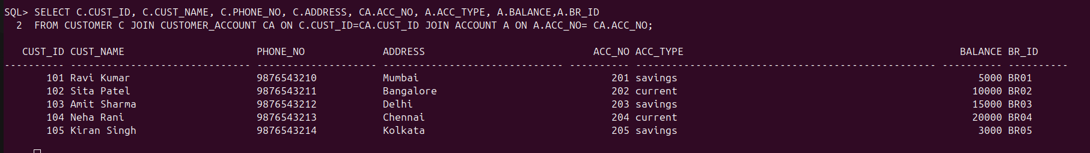

12. List the customer details having account type ‘savings’.

SSELECT C.CUST_ID, C.CUST_NAME, C.PHONE_NO, C.ADDRESS, A.ACC_TYPE
2 FROM CUSTOMER C JOIN CUSTOMER_ACCOUNT CA ON C.CUST_ID=CA.CUST_ID JOIN ACCOUNT A ON A.ACC_NO= CA.ACC_NO
3 WHERE A.ACC_TYPE='savings';
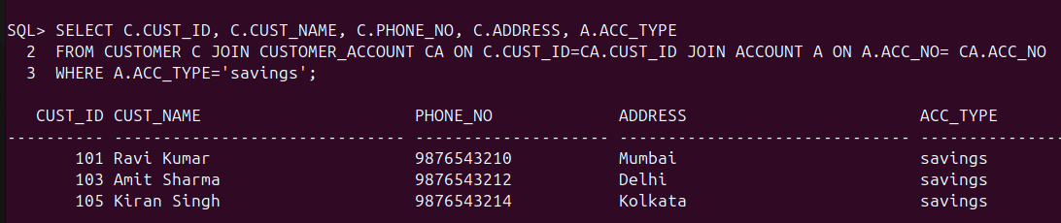
13. List the customer details having vehicle loan.

SELECT C.CUST_ID, C.CUST_NAME, C.PHONE_NO, C.ADDRESS
FROM CUSTOMER C JOIN Customer_Loan CL on C.cust_id=CL.cust_id join Loan L on L.loan_ID=CL.loan_ID where L.loan_type='Vehicle Loan';
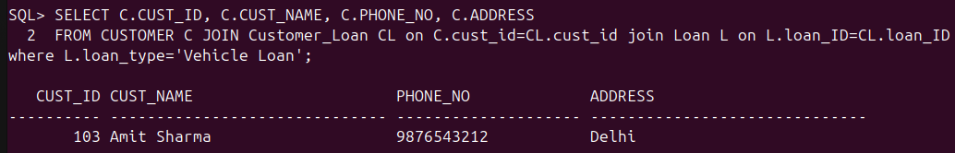
14. List the branch names of all accounts.

select A.acc_no, B.br_name from Account A join Branch B on A.br_id=B.br_id;
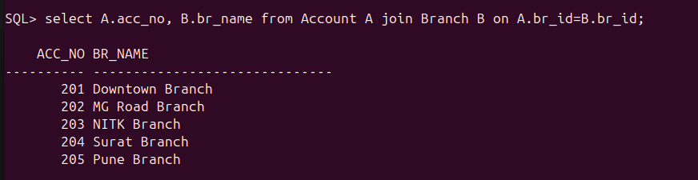
15. List the customer details going to ‘Surathkal’ branch.
SELECT C.CUST_ID, C.CUST_NAME, C.PHONE_NO, C.ADDRESS, B.br_name as Branch_name
2 from Customer C join Customer_Account CA on C.cust_ID= CA.cust_ID
3 join Account A on A.acc_no= CA.acc_no
4 join Branch B on B.br_id=A.br_id
5 where B.br_name= 'Surathkal';
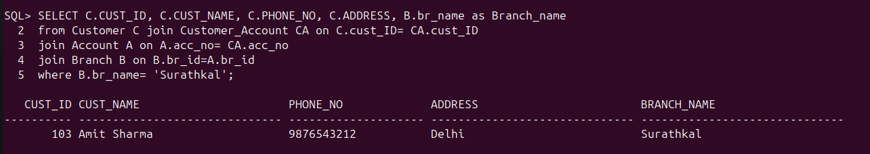

16. List the customers having loan account in ‘MG Road’ branch.

17. Find the customers having balance between 1000 to 10000 .
18. Give a bonus of rupees 100 to customers having more than 10000 balance.
19. Deduct 50 rupees from customers having less than 500 rupees in balance.
20. Give the customer details having home loan.
21. Give the customer details having home loan in ‘NITK’ branch.
22. Add a column NOMINEE to the customer table with data type varchar (50).
23. List all the account numbers in ascending order of their balance.
24. Count the number of customers having account type savings.
25. Count the number of customers for each account type.
26. Find the total balance in Savings account.
27. Find the average balance of Current account.
28. Find the average balance for each account type.
29. Find the customer details having maximum balance.
30. Find the average amount for vehicle loan.
31. Find the average balance in each branch.

